ALL MODULES SUCCESSFULLY HAVE BEEN IMPLEMENTED
1.POST:
For department:
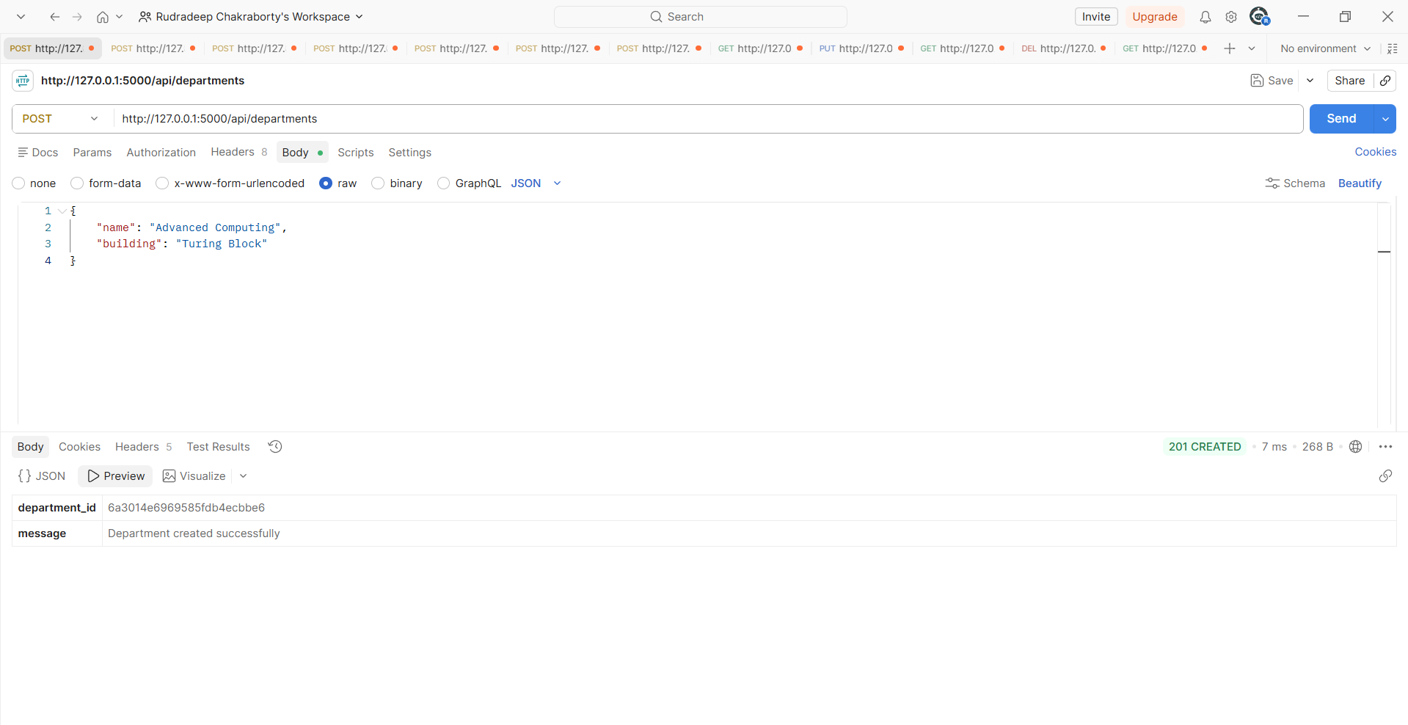
For Staff:
1. 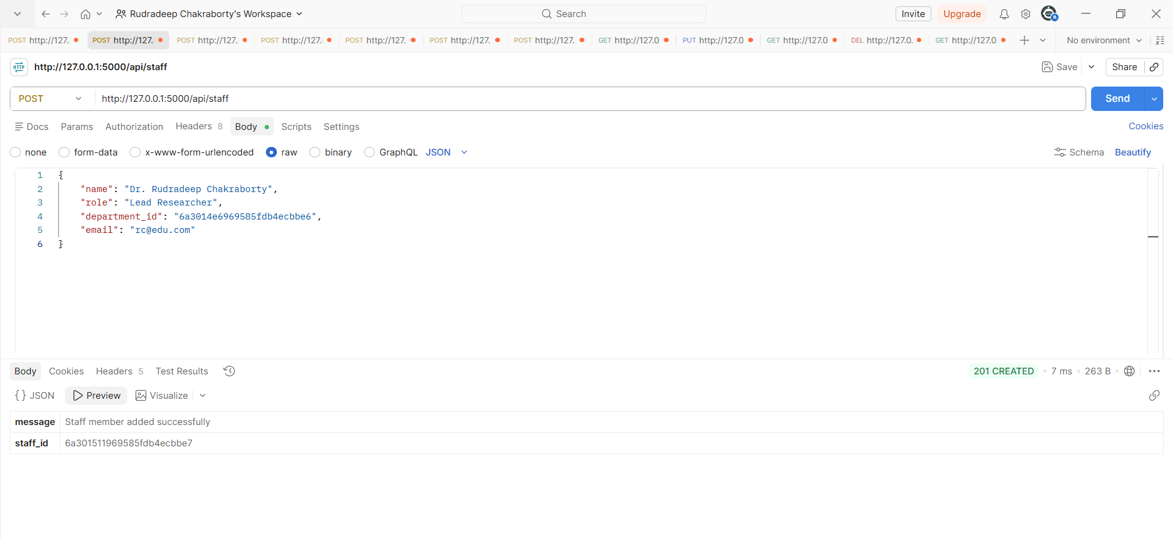
2.
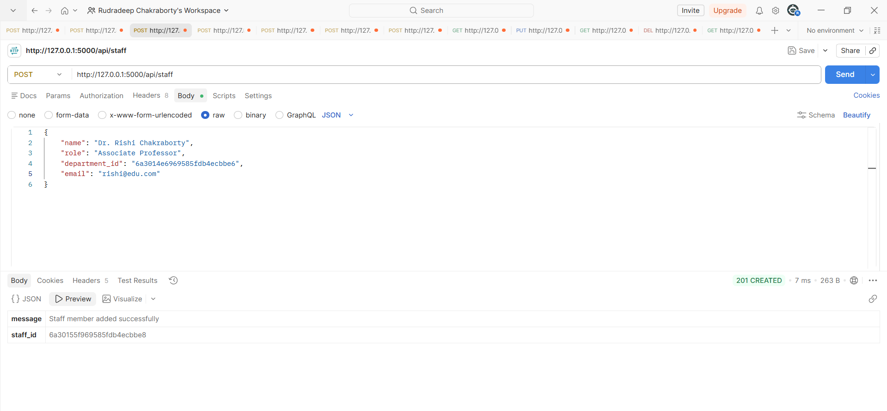

For Student:
1.
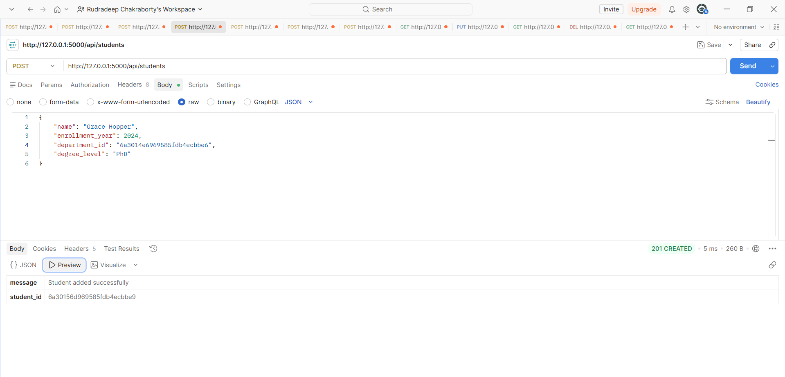
2.
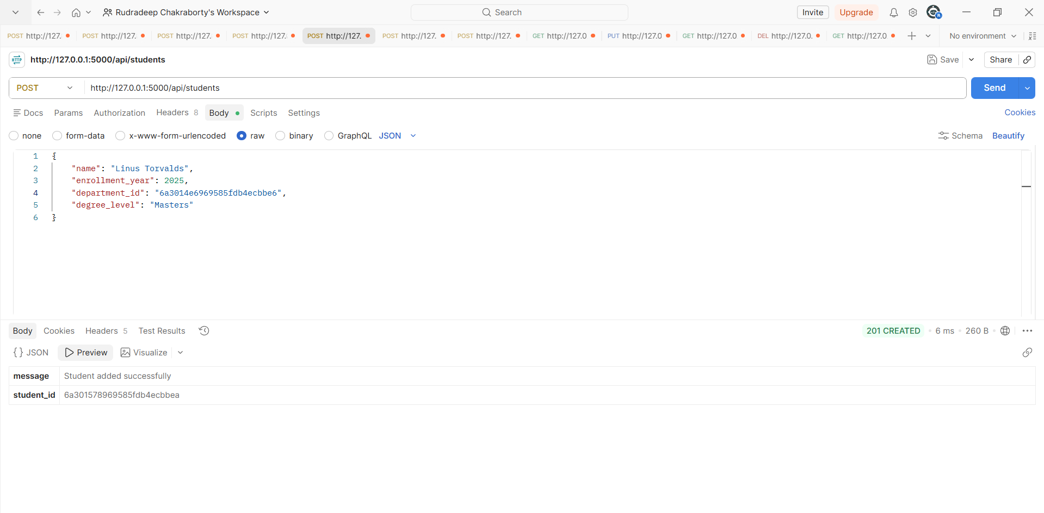

For publication:
1.
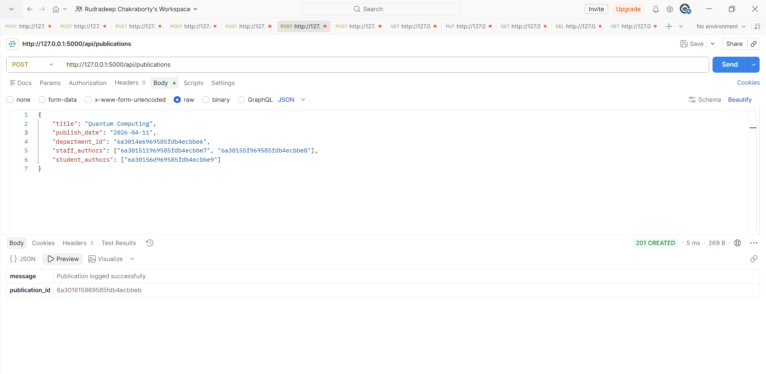

2.
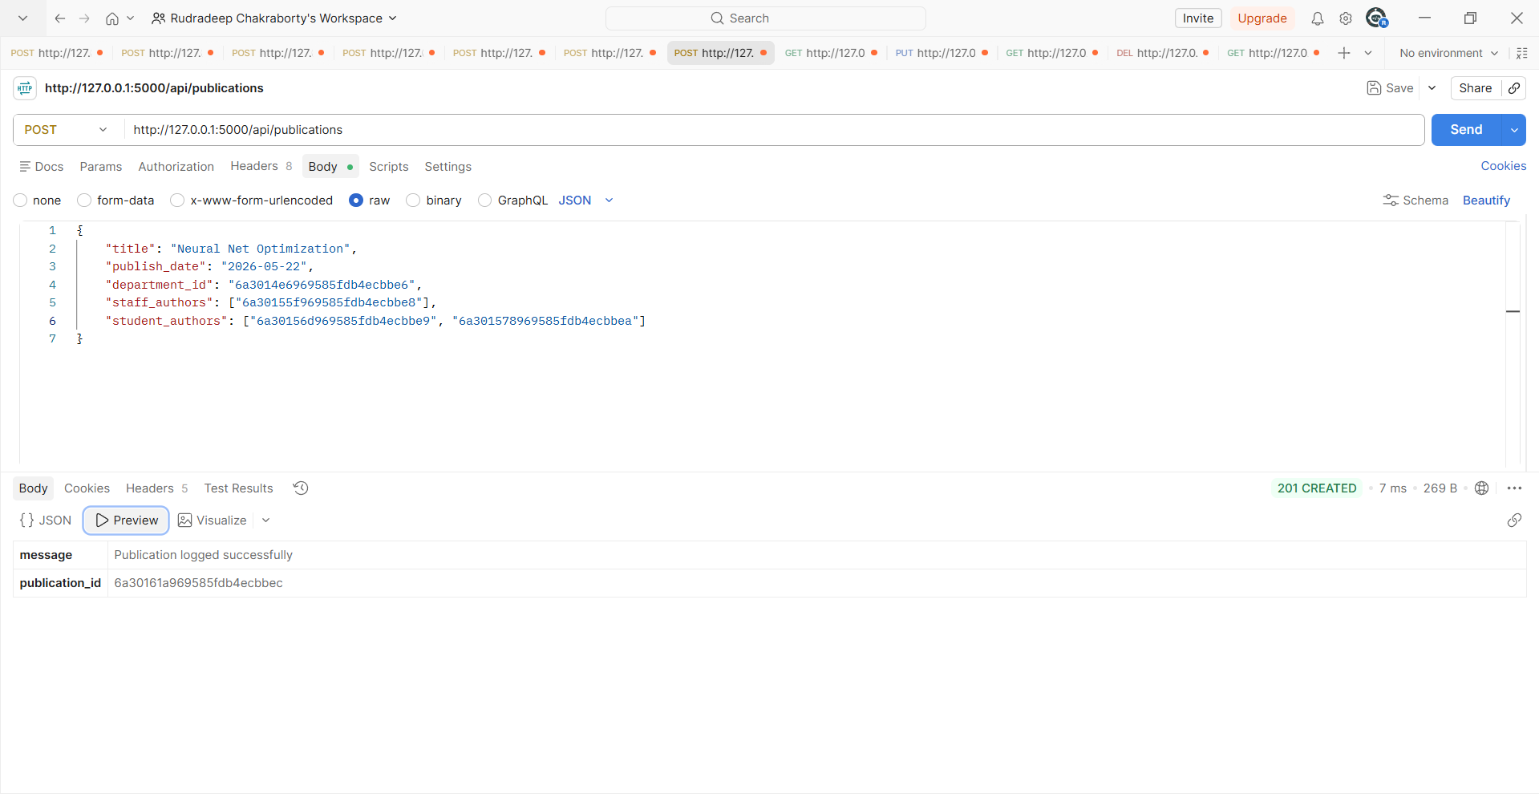

2.GET MODULE:
Fetch all publications:

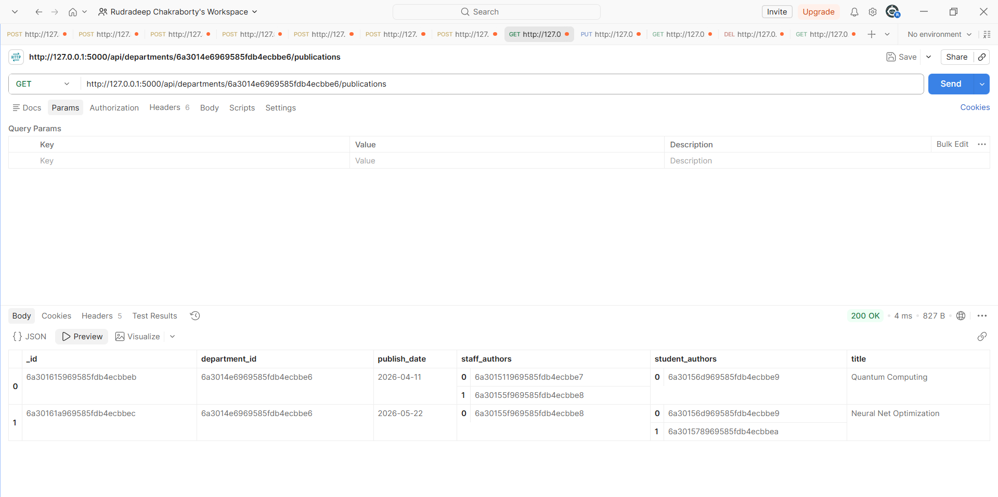
3.PUT MODULE:
Updating staff members role:
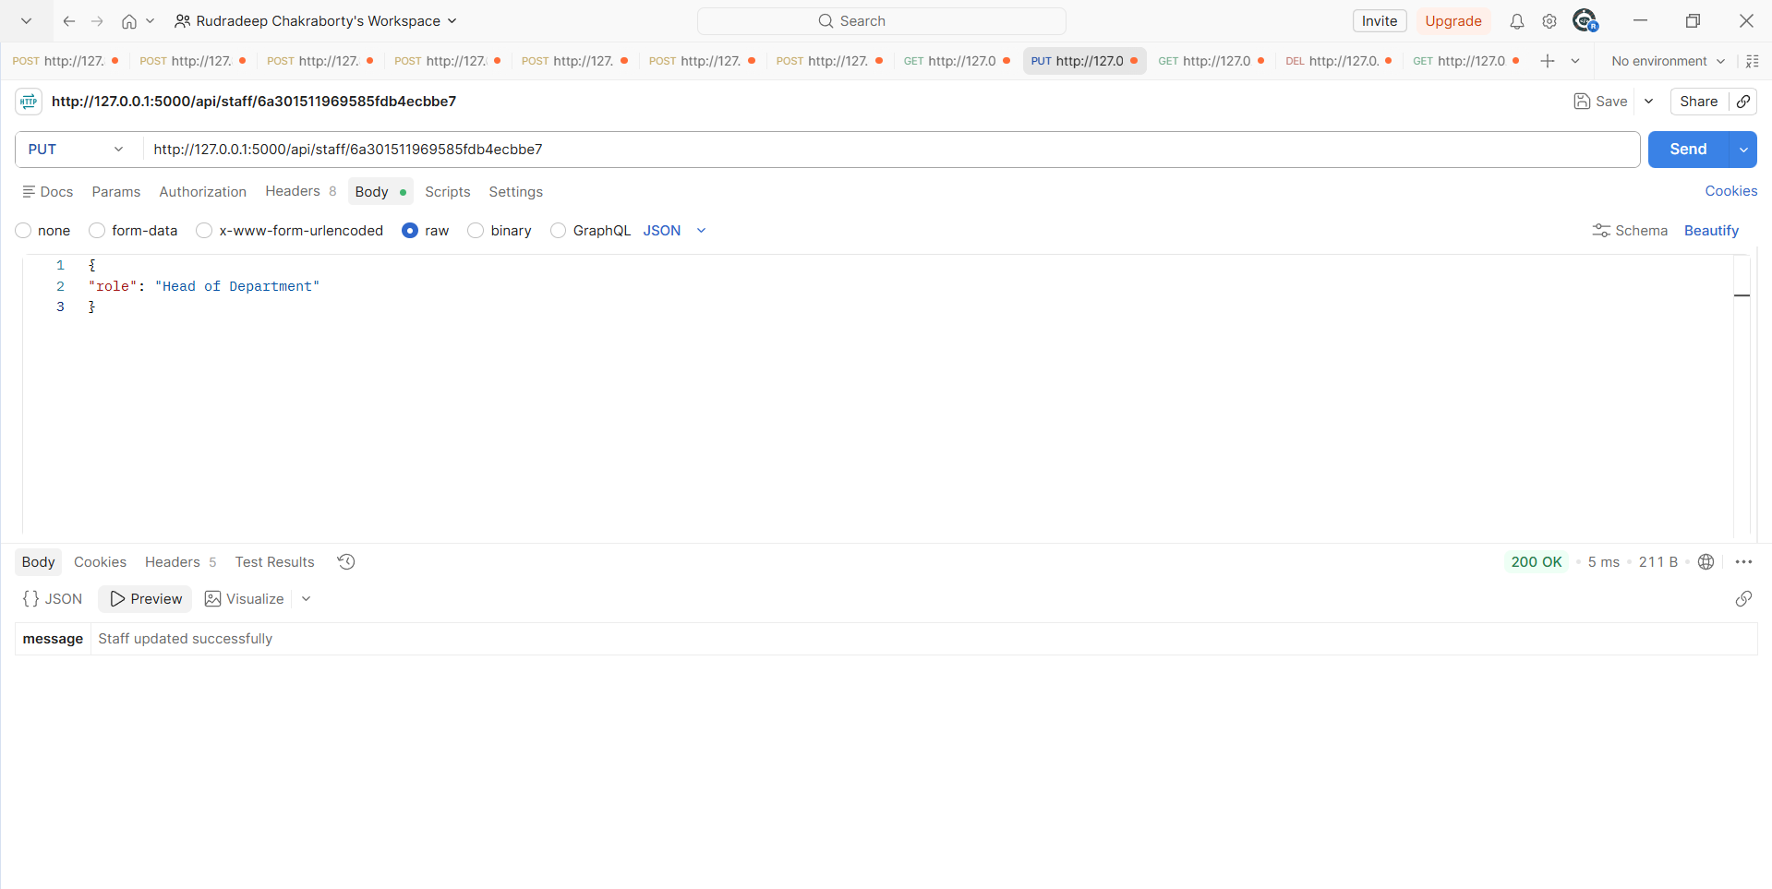

Verification via GET:
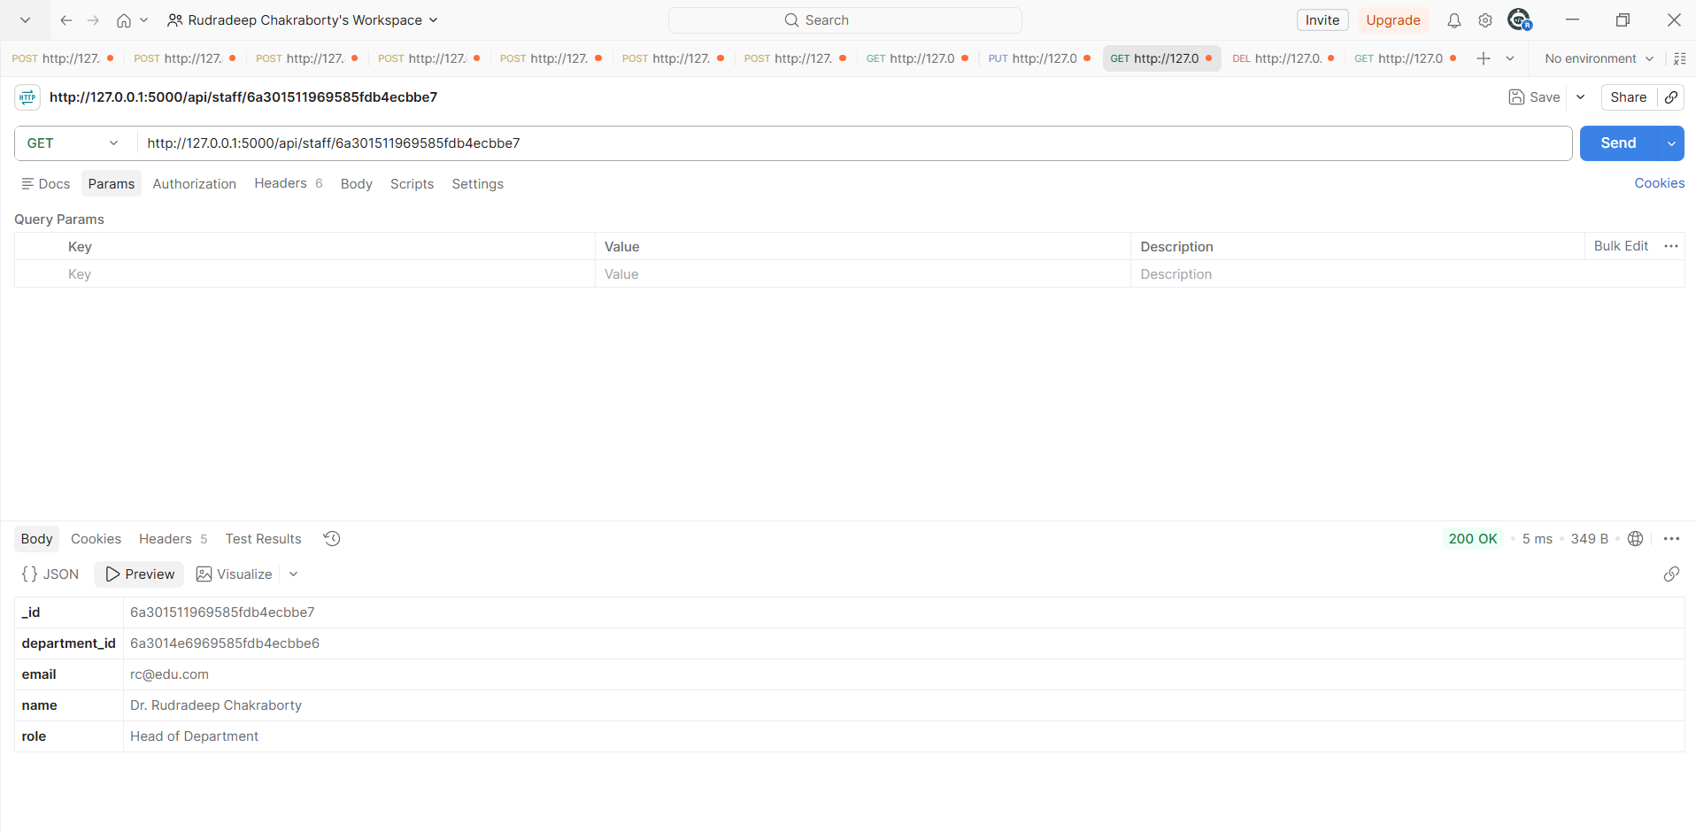
4.DELETE MODULE:
DELETING STUDENT 2:
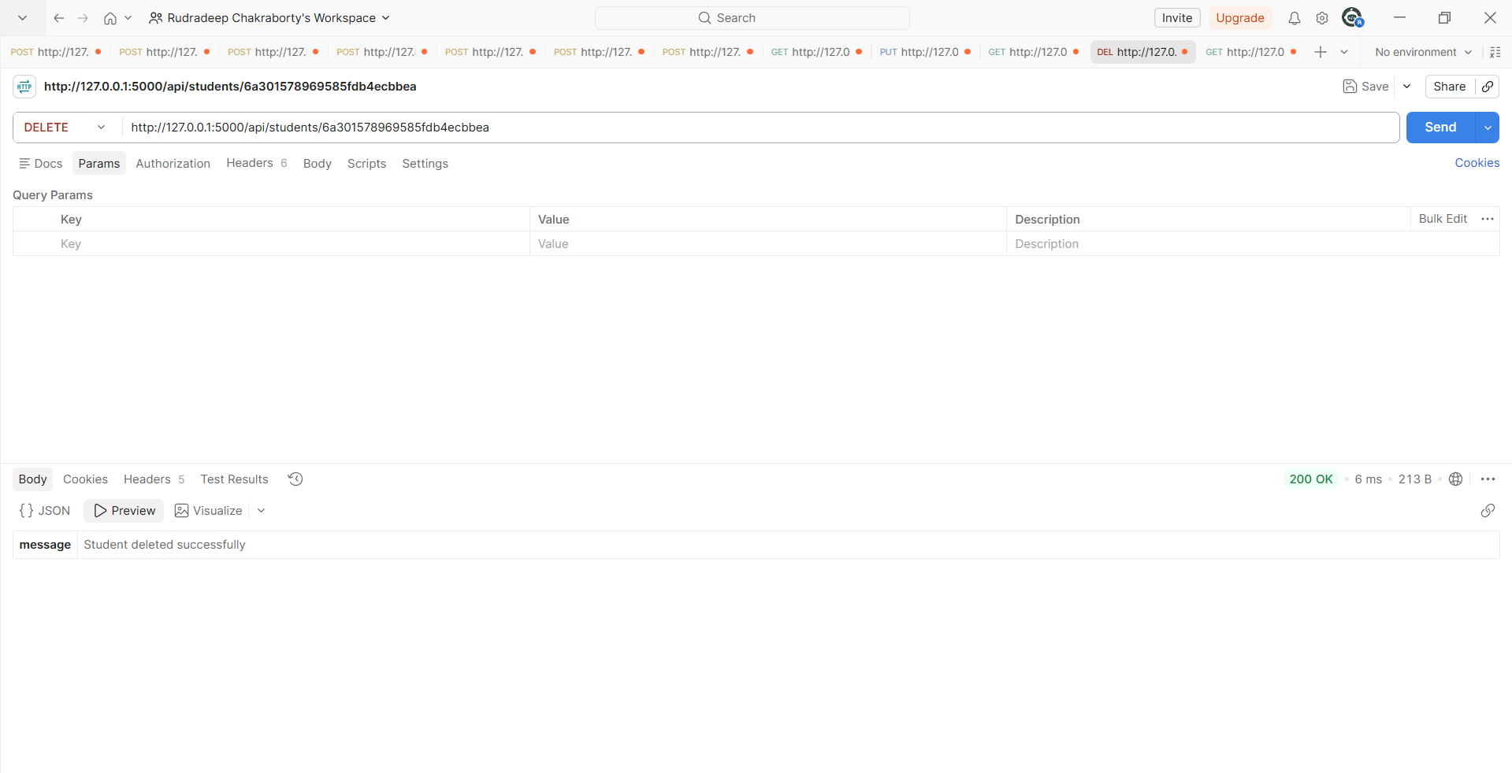

VERIFICATION VIA GET:
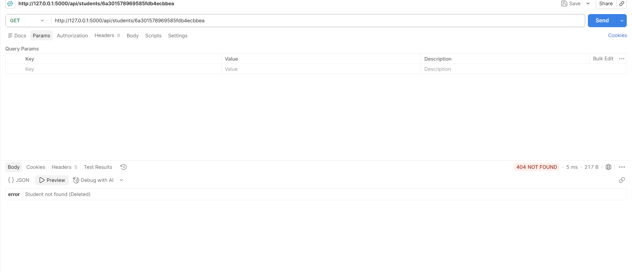

AND HENCE ALL THE MODULES HAVE BEEN SUCCESSFULLY IMPLEMENTED

PROOF THAT PYTHON SERVER IS RUNNING LOCALLY:
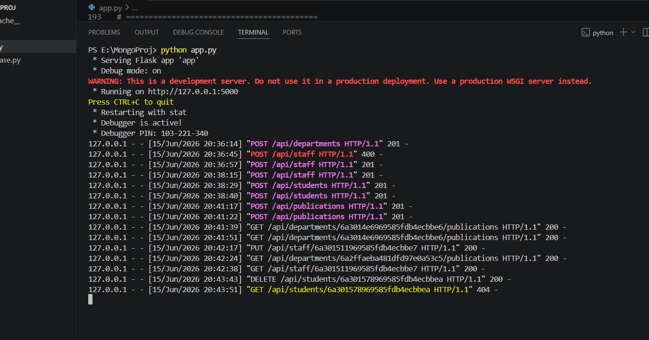

CODE GLIMPSE:
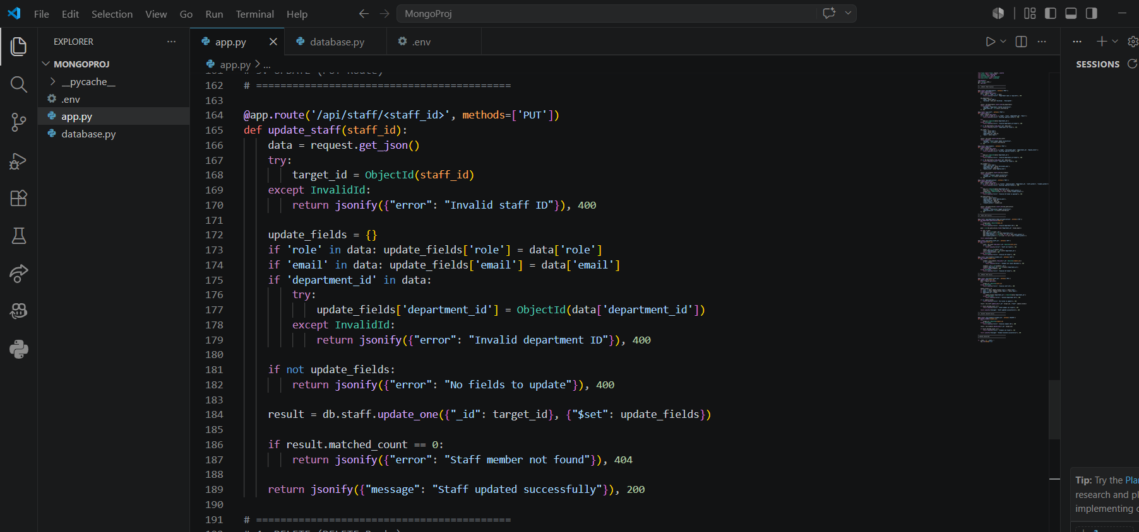
IDE USED: VS CODE
NAME: RUDRADEEP CHAKRABORTY , EMAIL: rudradeep.24bce11151@vitbhopal.ac.in
REGISTRATION NUMBER: 24BCE11151

